NEXTAG COMPANY

Gucci Zumi python mini bucket bag

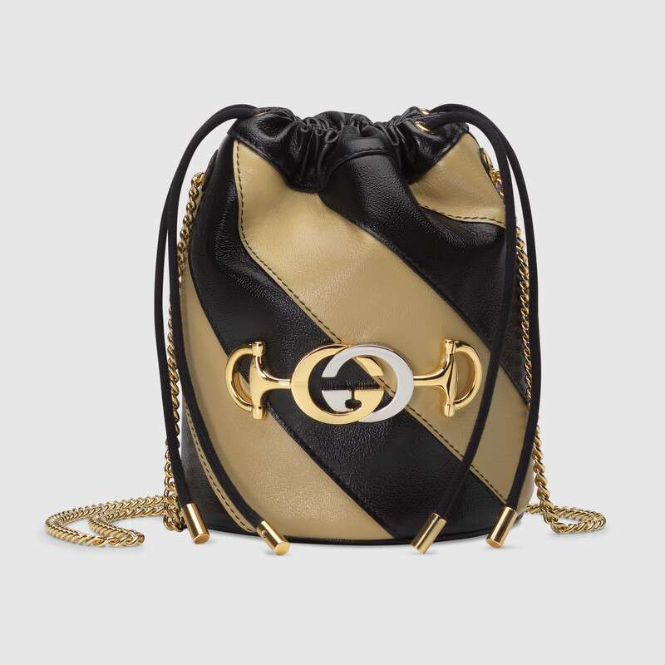

Style # 576432 0OLRX 9698

Product Description

A mini bucket bag enhanced by a rare archival detail—the Interlocking G Horsebit—in a mix of gold and silver tones. Presented in contrasting shades of beige and black and accentuated by diagonal stripes, the bag accessory is crafted from two different toned leathers, which are then sewn together.

Black leather trim with a vintage effect • Shiny gold- and silver-toned hardware

• Gucci Zumi • Interlocking G Horsebit—inspired by an archival piece,

the hardware combines two of the House's most historical motifs in a mix of metals • Chain strap with 23.6" drop • Detachable key ring • 2 card slots • Drawstring closure • Can also be worn as a cross body bag • Made in Italy

PRODUCT DETAILS

Style ‎576432 0OLRX 9698

A mini bucket bag enhanced by a rare archival detail—the Interlocking G Horsebit—in a mix of gold and silver tones. Presented in contrasting shades of beige and black and accentuated by diagonal stripes, the bag accessory is crafted from two different toned leathers, which are then sewn together.

* Beige and black diagonal matelassé leather with a vintage effect
* Black leather trim with a vintage effect
* Shiny gold- and silver-toned hardware
* Interlocking G Horsebit—inspired by an archival piece, the hardware combines two of the House's most historical motifs in a mix of metals
* Detachable key ring
* 2 card slots
* Chain strap with 23.6" drop
* Drawstring closure
* Can also be worn as a cross body bag
* Mini size: 7.5"W x 6.7"H
* Microfiber lining with a suede-like finish
* Made in Italy
* The model is 5'10" tall